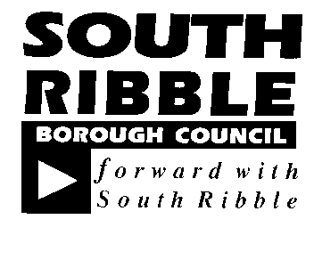  REPORT TO | ON
Scrutiny Committee | 23 January 2020
TITLE |  | REPORT OF
South Ribble Partnership Update |  | Interim Chief Executive

Is this report confidential? | No

Purpose of The Report

- To provide an update to the Scrutiny Committee on the revised structure of the Partnership and its governance arrangements, a progress update on the implementation of the Community Strategy and the arrangements for measuring impact and change.

Recommendations

- To note the report and progress made to date by South Ribble Partnership and provide any recommendations the committee feels the Partnership should consider.

Corporate Outcomes

- The report relates to the following corporate priorities:

Excellence, Investment and Financial Sustainability

Health, Wellbeing and Safety

Place, Homes and Environment

Projects relating to People in the Corporate Plan:

Our People and Communities

Background to The Report
- The purpose of the Partnership is to bring together people from across the public, private and voluntary and community sectors to make the Borough a better place to live and work. The Partnership through its collaborative approach seeks to;
- Create and develop service models so we work better together;
- Drive and influence opportunities for investment and growth for the Borough.

- In 2018, South Ribble Partnership began a review of the Community Strategy. Following significant consultation with both partners and communities, a new Community Strategy was launched in September 2019 at BAE’s Academy for Skills and Knowledge. The relaunch set out a clear vision for the Borough as well as a set of priorities that have been agreed with major stakeholders and key partners as a set of core priorities that all are focused on.

- The key priorities for the Partnership are;
  - Effective Partnerships: Driving effective reshaping of Local Services
  - Growth: Realising the Opportunities
  - Connected: Strong and Resilient Communities
  - Place: Attractive, Recognised and Known

- The full strategy is attached at Appendix A.
Proposals (E.G. Rationale, Detail, Financial, Procurement)
- Structure and Governance
- South Ribble Partnership is an unincorporated body and therefore does not have legal status. However, it has a clear and defined structure which is set out in its terms of reference.

- The partnership is made up of a Leaders Board and Executive Board with a number of thematic groups that are established by the Executive Board as required.

- The Leaders Board and Executive board meet jointly and form the body of ‘South Ribble Partnership’. They meet approximately 3 times per year. The Executive Board meets more frequently (bi-monthly) on its own to carry out the business of the Partnership and delivery of its Action Plan. It will report progress at the joint meeting of the Leaders and Executive Board.

- Each Board has a clear set of functions, which are summarised below;

- Leaders Board Function
- Act as a forum for identifying, analysing and solving problems across agencies;
- Approve the Community Strategy and its action plan;
- Monitor and review delivery of the Community Strategy and its action plan;
- Act to remove blockages and barriers to implementing the Community Strategy work programme;
- Ensure that issues are addressed through a cross-cutting approach and the work of the Partnership is cohesive and joined up.

- Executive Board Function
- Take decisions and allocate resources to enable effective delivery of the Community Strategy;
- Share relevant data and intelligence to inform Partnership decisions;
- Develop the Partnership’s overall targets for delivery and monitor performance;
- Reshape policies, processes and structures to enable innovative joint working across organisational boundaries, including developing new models of joined-up service delivery;
- Monitor risks facing the Partnership and ensuring mitigation plans are in place, where required;
- Prepare reports for the joint Leaders and Executive Board meetings.

- Chairing Arrangements
- The Chair of the Leaders Board acts as the formal chair of South Ribble Partnership and when required as the spokesperson on behalf of the Partnership. The Chair of the Leaders Board is elected from amongst the Board members. At the meeting of December 17th, the Chair was duly elected, and Jaqueline De-Rose, Chief Executive of Progress Housing Group was appointed as Chair for a period of 2 years.

- The role of Vice Chair of the Leaders Board must be held by an appointed elected member of South Ribble Borough Council (if not elected as Chair of the Partnership, Leaders Board). The reason for this is due to the support provided by the Council as its responsible body. The Council provides administrative and officer-based support that co-ordinates and manages the delivery of programmes/work streams.

- The Executive Board elect their Chair and Vice Chairs from amongst their members. Nominations have been received and they are to be elected at their next meeting on January 24th 2020.

- Community Strategy Action Plan
- In September 2019, the Leaders and Executive Board defined a number of work streams for the Partnership to be focused on over the next 12 months. These work streams directly link to the key priorities of Effective Partnerships, Growth, and Connected.

- Strand 1, Referrals and Pathways
Part A: Education, Skills, Aspirations (Growth):
- Develop initial skills/confidence;
- Preparedness for work;
- Developing aspirations;
- Advancing social mobility.
Part B: Health (Effective Partnerships)
- Early Action and Intervention
- Integrated services
- Community based approaches to self-care/management and prevention

- Strand 2, Connected Communities
Developing Volunteering (Connected)
- Recruitment (including skilled volunteering)
- Incentivised Volunteering / Engagement

- Strand 3, Communication and Culture
Part A: Internal Communications (Effective Partnerships)
- Improve communication across the Partnership in the form of a Communication Strategy. How we can communicate more effectively as a Partnership
Part B: External Communications
- Wider communication in terms of organisations understanding what different services/opportunities are being delivered. Elements of this included reference to Refernet which provides a digital platform which details different services available to residents/service users.

- Following the launch of the strategy, a series of thematic group workshops have taken place between September and December to develop an action plan to identify activities and shape a clear action plan.

- The Partnership’s action plan has now been adopted by the Leaders and Executive Boards in December 2019. A full copy is attached in appendix B. However, a summary of the 10 defined projects are below.
Theme | Objective 1 | Objective 2 | Objective 3
EFFECTIVE PARTNERSHIPS  Executive Board | Develop a Data Dashboard | Communication Framework
GROWTH  Education, Skills, Aspirations | Identify the current services available across the borough and map these as pathways in the form of an interactive infographic | Capitalise on the Local Government Association (LGA) ‘Work Local’ scheme to gain funding to support a programme focusing on improving opportunities for those within South Ribble who are furthest away from employment.
CONNECTED  Developing Volunteering | Agree to implement an approach within partner organisations to enable employees to give their skills to voluntary organisations for a certain period per year. | Utilise a Central Platform(s) for Volunteering Opportunities across South Ribble | Tempo Time Credits
EFFECTIVE PARTNERSHIPS  Health | Provide infrastructure to support the South Ribble Integrated Team | Implement Refernet | Identify the current services available across the borough and map pathways

- Performance Framework and Measuring success
- A performance management framework is being developed and yet to be formally adopted by the Leadership and Executive Board. However, there are clear structures in place to manage projects and activities, which have been agreed.

- The Executive Board receives a performance report at each meeting and a subsequent period report to the Leaders and Executive Boards.

- A summary of the decision making, and performance structure is set over the page.

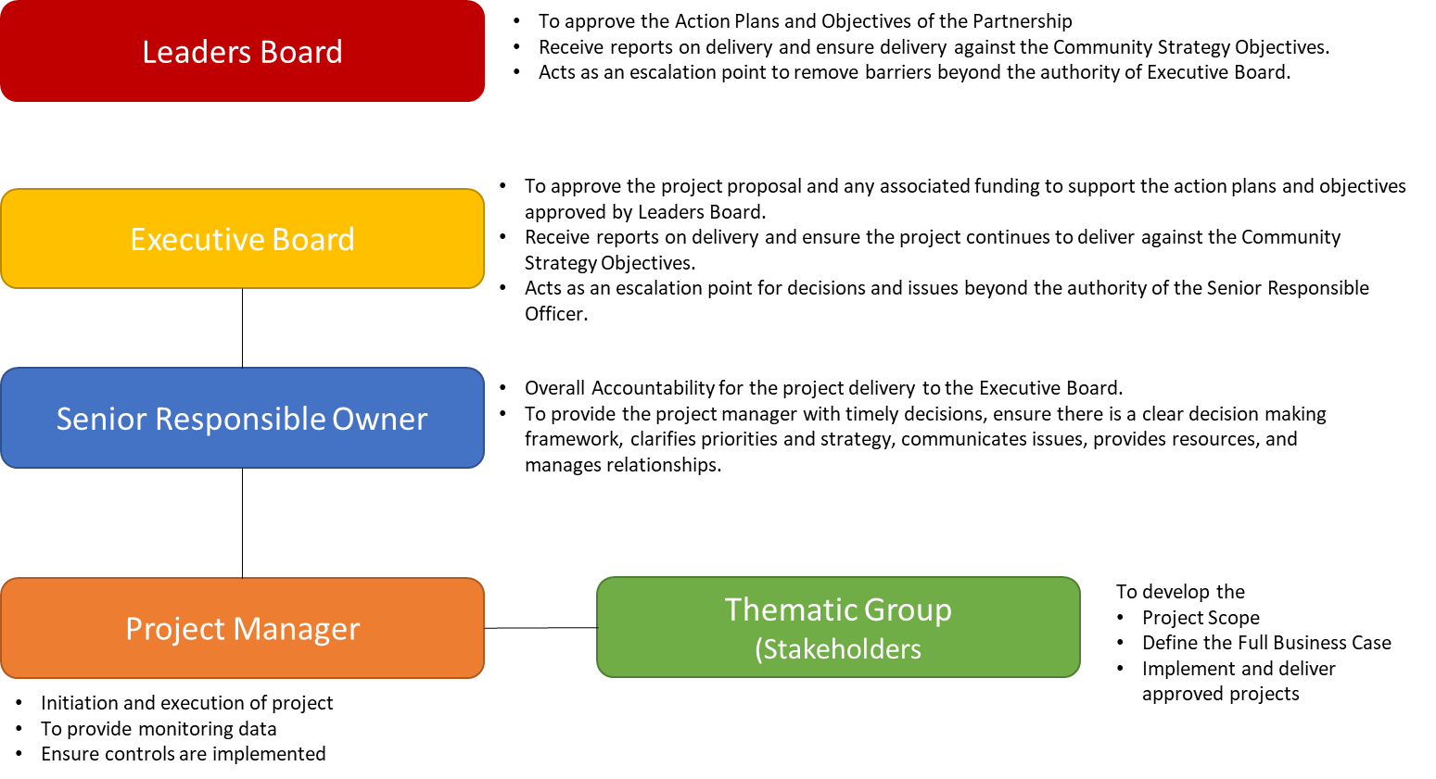

- Key performance measures and key indicators are being developed and are to be agreed at the Leaders and Executive Board Meeting in March 2020. The Partnership has agreed that its suite of indicators need to;
- relate to what the Partnership can contribute to and have influence over
- be forward looking to demonstrate the ‘shift’ made (provide a picture of movement, backwards, forwards and trend)

- In developing its performance framework, the Partnership is seeking to establish a partnership score card, monitoring report and is exploring development of a social progress index. These are developmental and an update can be provided to Scrutiny once available.

- Strategic Link to the Council’s Corporate Plan
- It is important that the work of the Partnership and the Community Strategy is integrated into the Council’s own Corporate Plan. There are several of the Partnership’s projects and activities that relate directly to the Corporate Plan.

- The Health Thematic Group seeks to deliver on the Partnership’s priority of effective partnerships by;
- putting in place solutions to use information more effectively so that they make better decisions are able to make better decisions about the services they provide.
- work together to align and share resources and integrate services to improve the way people are supported by local services.

- This work seeks to align with the Integrated Care Partnership and seeks in particular to support the Wellbeing and Health in Integrated Networks (WHIN) platform, where the objective is to use co-production with partners and communities to redesign pathways that integrate partners and systems.

- The work of the Partnership under its health strand will impact on a number of key corporate plan objectives and projects and efforts will be made to ensure that they are linked with the work of the Partnership. This includes the priorities and activities listed in the Corporate Plan;
- Supporting the South Ribble Dementia Action Alliance and delivery of its annual Action Plan.
- Reduce the number of homeless through developing a health and prevention focused approach.
- Provide residents and businesses with the skills, expertise and resources to interact with the Council and other organisations digitally.
- Review and support the recommendations of the Scrutiny Review, ‘Mind the Gap’.
- Work with partners to ensure residents have access to first class advice services.
- Review the Local Plan which defines planning policies, consulting on options and preparing a draft Central Lancashire Local Plan.

- The work of the Partnership with regards its priority ‘Connected’ relates directly to the Corporate Plans objective to;
- Develop the Council's approach to volunteering and active citizens, enhancing the council's own opportunities to volunteer with us and for employees to volunteer as well.

- In the immediate term these linkages translate to several live projects on the ground that include;

- Refernet | - Access to Advice Services | - Interacting with the Council Digitally
- Time Credits | - Council’s approach to Volunteering | - Mind the Gap
- South Ribble Integrated Team | - Mind the Gap  - First Class Advice Services | - Reducing the number of homeless through developing a health and prevention focused approach

Consultation Carried Out and Outcome of Consultation

- A significant number of organisations are involved within the Partnership. These are listed within the Action Plan, together with a list of all key Board members in Appendix C.

- Regular meetings form the basis of consultation with key stakeholders and is reflected in decisions taken by the Partnership.

- A significant amount of consultation was undertaken in developing the strategy which was reported to Council on 6th February 2019

Air Quality Implications

- N/A

Comments of The Statutory Finance Officer

- The financial implications of the Council’s corporate plan projects have been incorporated into the budget and Medium-Term Financial Strategy. A number of these are linked with the work of the Partnership as explained in the body of the report. The balance of Performance Reward Grant has been ring-fenced for delivering Partnership projects.

Comments of The Monitoring Officer

- There are no legal implications as a result of this update report.
OTHER IMPLICATIONS:

- Risk  - Equality & Diversity | Key risks to the Partnership are;  - Finance Resource. Performance reward grant is almost exhausted but should be able to facilitate the immediate/short term deliveries. The Partnership did not have ‘project’ based funding in its early years and implementation of future projects will rely on partners agreeing best use of resources available.  - Capacity of organisations. It is essential organisations can provide sufficient capacity to support activities through operational leaders/officers who can provide the relevant skills and expertise.  The Policy, Performance and Partnerships team can provide capacity to organise, co-ordinate and support meetings and associated chairs.  The Partnership is committed to Equality and Diversity and undertake relevant Equality Impact assessments against its projects as a matter of routine.  In everything the Partnership does it seeks to be as inclusive as possible and is particularly focused around implementing solutions to address inequalities.

BACKGROUND DOCUMENTS

Report to Council – 6th February 2019, South Ribble Community Strategy 2019-24

APPENDICES (or There are no appendices to this report)

Appendix A - South Ribble Community Strategy 2019 - 2024
Appendix B - South Ribble Partnership Action Plan 2020
Appendix C – List of Leaders and Executive Board Member Organisations

Gary Hall
Interim Chief Executive

Report Author: | Telephone: | Date:
Howard Anthony, South Ribble Partnership Manager | 01772 625546 | 13-01-2020

